Partial / residual correlation: NZDUSD and USDCAD
Method 07 / daily log returns / leave-currency-out USD factor / Alpari D1 full available history

Study setup
Logical pair: NZDUSD , USDCAD
Broker symbols: NZDUSD_i , USDCAD_i
Snapshot: 2026-11-03_majors_alpari_D1
Timeframe: D1
Matched return window: 1999-01-05 to 2026-11-02 (UTC bar dates)
Matched return count n: 7148
Dropped unfinished last bar dated 2026-11-03 UTC after a tick-volume check against the prior complete day.
USD-strength sign rule: minus log return when USD is the quote (EURUSD, GBPUSD, AUDUSD, NZDUSD); plus log return when USD is the base (USDJPY, USDCHF, USDCAD). EURGBP is never a constituent.
Control z constituents (5): EURUSD, GBPUSD, AUDUSD, USDJPY, USDCHF
z_t = equal-weight mean of those USD-strength returns on the same day
Complete matched rows (Excel): NZDUSD-USDCAD_Partial_D1.xlsx
Complete matched rows (HTML table): NZDUSD-USDCAD_Partial_D1_data.html

Method carried forward
Partial / residual correlation regresses each matched daily log return of close, ln(close_t / close_t-1), on the same leave-currency-out USD strength factor z, then takes Pearson correlation of the two residual series. Quotes are not inverted. z is the equal-weight mean of USD-strength returns from other majors that do not share a non-USD currency with either leg; EURGBP is never a constituent. USD-strength is minus the log return when USD is the quote (EURUSD, GBPUSD, AUDUSD, NZDUSD) and plus the log return when USD is the base (USDJPY, USDCHF, USDCAD). OLS uses an intercept on each leg. rho_partial is symmetric under swap of the two symbols. It describes leftover linear co-movement after removing linear z; it is not a cause, not a lead, and not a trading signal. Daily rows are not independent and residuals are estimated, so the two-sided p-value and Fisher interval are secondary. Same-sample raw Pearson r is a side check only.

Regression on z
leg | intercept_a_or_c | slope_b_or_d | R2
NZDUSD | 1.333e-05 | -1.1062092 | 0.45969726
USDCAD | -9.23e-06 | 0.57604043 | 0.27521901

Results
rho_partial: -0.371754
Two-sided p-value: 4.07705e-233
Approximate 95% Fisher interval: [-0.391562, -0.351601]
Same-sample raw Pearson r: -0.588329
rho_partial minus r: 0.216575

Conclusion
Over 7148 matched daily rows for NZDUSD and USDCAD after removing a leave-currency-out USD factor built from 5 constituents, rho_partial is -0.3718 (negative, weak residual linear link in this sample). Approximate 95% Fisher interval: [-0.3916, -0.3516]. Same-sample raw Pearson r is -0.5883 (partial minus r = 0.2166). Leg R-squared on z: NZDUSD=0.4597, USDCAD=0.2752. Two-sided p under the usual independent-pairs model is 4.077e-233; residuals are estimated and daily FX rows are linked, so treat p as secondary. This does not establish cause, lead-lag, or a lasting trading rule.

Charts
Daily closes
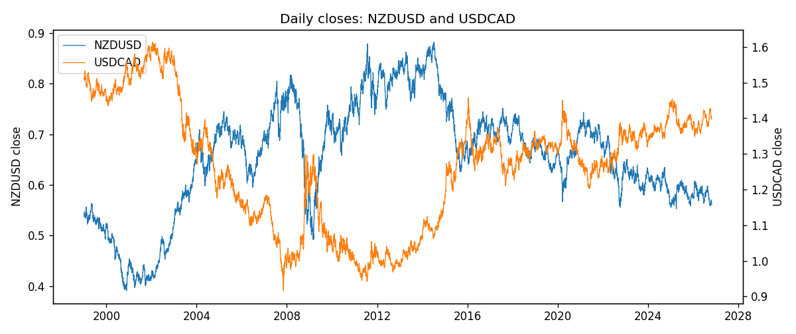
Log returns and control z
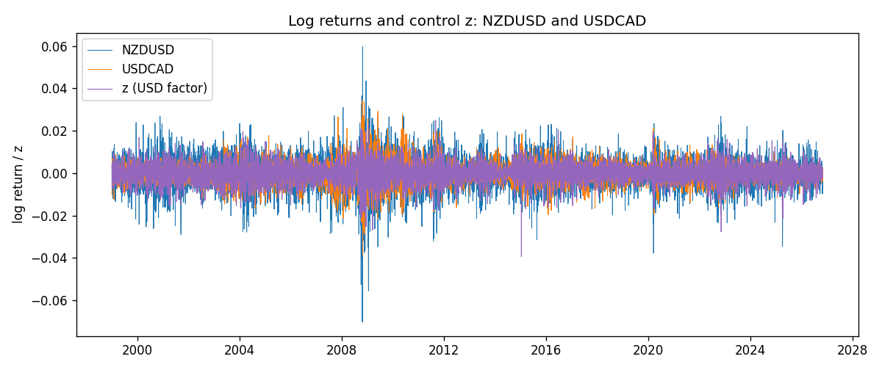
Residual scatter e_x vs e_y
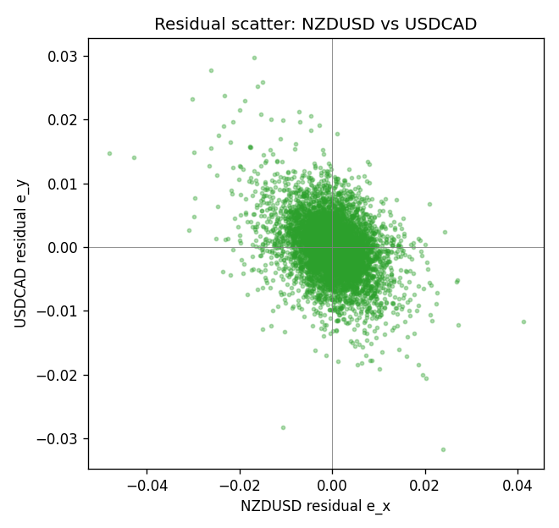

Data report
Every matched row that entered the partial correlation is stored in the sibling Excel workbook named NZDUSD-USDCAD_Partial_D1.xlsx. That file is the complete data archive for redrawing charts. Embedding all rows as a Word table is impractical at this length; the Word file holds the column list, column summaries, and the first and last 15 matched rows.
Columns: time, NZDUSD_open, USDCAD_open, NZDUSD_high, USDCAD_high, NZDUSD_low, USDCAD_low, NZDUSD_close, USDCAD_close, NZDUSD_tick_volume, USDCAD_tick_volume, NZDUSD_spread, USDCAD_spread, NZDUSD_real_volume, USDCAD_real_volume, NZDUSD_log_return, USDCAD_log_return, usd_strength_EURUSD, usd_strength_GBPUSD, usd_strength_AUDUSD, usd_strength_USDJPY, usd_strength_USDCHF, z, NZDUSD_fitted, USDCAD_fitted, NZDUSD_resid, USDCAD_resid
Column summaries (matched calculation rows)
column | count | mean | std | min | 25% | 50% | 75% | max
NZDUSD_open | 7148 | 0.65680048 | 0.1080291 | 0.3913 | 0.5917475 | 0.668695 | 0.72504 | 0.88218
USDCAD_open | 7148 | 1.2664001 | 0.16881677 | 0.9168 | 1.1174225 | 1.29842 | 1.3719025 | 1.6183
NZDUSD_high | 7148 | 0.66072183 | 0.10852081 | 0.3961 | 0.595065 | 0.67222 | 0.729525 | 0.88421
USDCAD_high | 7148 | 1.2712993 | 0.16876756 | 0.9336 | 1.1224 | 1.30385 | 1.3760825 | 1.619
NZDUSD_low | 7148 | 0.65311385 | 0.10762321 | 0.3897 | 0.588355 | 0.66451 | 0.72113 | 0.87988
USDCAD_low | 7148 | 1.2618444 | 0.16884966 | 0.9056 | 1.1128375 | 1.29351 | 1.367575 | 1.6102
NZDUSD_close | 7148 | 0.65687963 | 0.10802405 | 0.3907 | 0.592165 | 0.66876 | 0.72518 | 0.8822
USDCAD_close | 7148 | 1.2664179 | 0.16878481 | 0.916 | 1.117435 | 1.298405 | 1.3722025 | 1.6137
NZDUSD_tick_volume | 7148 | 69051.458 | 123370.73 | 17 | 5742 | 34119 | 58667.5 | 1127682
USDCAD_tick_volume | 7148 | 81445.79 | 147602.47 | 56 | 5642.25 | 41126 | 71764.5 | 1410818
NZDUSD_spread | 7148 | 30.128428 | 25.588679 | 0 | 9 | 17 | 40 | 80
USDCAD_spread | 7148 | 23.322888 | 18.222444 | 0 | 9 | 17 | 40 | 60
NZDUSD_real_volume | 7148 | 1.678526e+10 | 8.5194876e+10 | 0 | 0 | 0 | 0 | 2.705649e+12
USDCAD_real_volume | 7148 | 1.8476363e+10 | 9.6948735e+10 | 0 | 0 | 0 | 0 | 2.5751613e+12
NZDUSD_log_return | 7148 | 1.914e-05 | 0.00764519 | -0.07027433 | -0.00424201 | 0.00023666 | 0.004586 | 0.05966839
USDCAD_log_return | 7148 | -1.226e-05 | 0.00514518 | -0.03859748 | -0.00283513 | 4.873e-05 | 0.00272781 | 0.03436319
usd_strength_EURUSD | 7148 | 2.16e-06 | 0.0058013 | -0.03433183 | -0.00325609 | -0 | 0.00324218 | 0.03123819
usd_strength_GBPUSD | 7148 | 1.992e-05 | 0.00564699 | -0.03112653 | -0.00318167 | -3.426e-05 | 0.0031217 | 0.08388241
usd_strength_AUDUSD | 7148 | -3.157e-05 | 0.00755018 | -0.0806166 | -0.00415111 | -0.00029168 | 0.00385014 | 0.08602525
usd_strength_USDJPY | 7148 | 5.267e-05 | 0.00620906 | -0.03908203 | -0.00319392 | 0.00012736 | 0.00340928 | 0.05184024
usd_strength_USDCHF | 7148 | -6.945e-05 | 0.0065937 | -0.19545699 | -0.00334697 | 8.15e-05 | 0.00331954 | 0.09051364
z | 7148 | -5.25e-06 | 0.00468584 | -0.0393924 | -0.00264752 | 6.934e-05 | 0.00269941 | 0.02497718
NZDUSD_fitted | 7148 | 1.914e-05 | 0.00518352 | -0.02761666 | -0.00297278 | -6.338e-05 | 0.00294204 | 0.04358957
USDCAD_fitted | 7148 | -1.226e-05 | 0.00269923 | -0.02270085 | -0.00153431 | 3.071e-05 | 0.00154573 | 0.01437863
NZDUSD_resid | 7148 | -0 | 0.00561962 | -0.04813419 | -0.00295233 | 0.00015717 | 0.00309975 | 0.04116345
USDCAD_resid | 7148 | 0 | 0.00438031 | -0.03166545 | -0.0024045 | -1.8e-05 | 0.00237466 | 0.02975231
First 15 matched rows (selected columns)
time | NZDUSD_close | USDCAD_close | NZDUSD_log_return | USDCAD_log_return | z | NZDUSD_fitted | USDCAD_fitted | NZDUSD_resid | USDCAD_resid
1999-01-05 | 0.5372 | 1.5123 | -0.0018597736 | -0.010131666 | 0.0024601305 | -0.00270809 | 0.0014079006 | 0.00084831639 | -0.011539566
1999-01-06 | 0.5383 | 1.5118 | 0.0020455609 | -0.0003306769 | 0.0042975611 | -0.0047406728 | 0.002466335 | 0.0067862337 | -0.0027970119
1999-01-07 | 0.5417 | 1.5141 | 0.0062963171 | 0.0015202092 | -0.0073228694 | 0.0081139546 | -0.0042275028 | -0.0018176375 | 0.0057477119
1999-01-08 | 0.5414 | 1.511 | -0.00055396548 | -0.0020495197 | 0.0045502676 | -0.005020219 | 0.0026119041 | 0.0044662536 | -0.0046614239
1999-01-11 | 0.547 | 1.5057 | 0.010290425 | -0.0035137769 | -0.0010664129 | 0.0011930048 | -0.00062353093 | 0.0090974204 | -0.002890246
1999-01-12 | 0.5441 | 1.5157 | -0.0053157489 | 0.0066194721 | 0.0041135159 | -0.0045370803 | 0.0023603175 | -0.00077866867 | 0.0042591546
1999-01-13 | 0.5387 | 1.5226 | -0.0099742238 | 0.0045420214 | -0.0044421119 | 0.0049272342 | -0.00256807 | -0.014901458 | 0.0071100915
1999-01-14 | 0.5386 | 1.5332 | -0.00018564931 | 0.0069376546 | -0.00033327724 | 0.00038200333 | -0.00020121512 | -0.00056765264 | 0.0071388698
1999-01-15 | 0.5382 | 1.5245 | -0.00074294208 | -0.0056905671 | 0.0056525169 | -0.0062395374 | 0.0032468443 | 0.0054965953 | -0.0089374114
1999-01-18 | 0.5372 | 1.526 | -0.0018597736 | 0.00098344542 | -0.0017761796 | 0.0019781552 | -0.0010323852 | -0.0038379289 | 0.0020158306
1999-01-19 | 0.5382 | 1.5302 | 0.0018597736 | 0.002748513 | -0.0029238297 | 0.0032476963 | -0.0016934781 | -0.0013879227 | 0.004441991
1999-01-20 | 0.5404 | 1.5211 | 0.0040793678 | -0.0059646885 | 0.0017373047 | -0.0019084936 | 0.00099152381 | 0.0059878614 | -0.0069562123
1999-01-21 | 0.5426 | 1.5146 | 0.0040627941 | -0.0042823796 | -0.00046224992 | 0.0005246741 | -0.0002755086 | 0.00353812 | -0.004006871
1999-01-22 | 0.5361 | 1.5184 | -0.012051689 | 0.0025057712 | 0.0033757591 | -0.0037209669 | 0.0019353398 | -0.0083307224 | 0.00057043139
1999-01-25 | 0.5342 | 1.5197 | -0.0035504102 | 0.00085579808 | 0.00017459785 | -0.00017981278 | 9.1341461e-05 | -0.0033705974 | 0.00076445662
Last 15 matched rows (selected columns)
time | NZDUSD_close | USDCAD_close | NZDUSD_log_return | USDCAD_log_return | z | NZDUSD_fitted | USDCAD_fitted | NZDUSD_resid | USDCAD_resid
2026-10-13 | 0.56127 | 1.4214 | 0.0047326165 | -0.0046395653 | -0.0030546687 | 0.0033924317 | -0.0017688466 | 0.0013401848 | -0.0028707187
2026-10-14 | 0.55918 | 1.42356 | -0.0037306483 | 0.0015184751 | 0.0026417295 | -0.0029089766 | 0.001512509 | -0.00082167167 | 5.9660286e-06
2026-10-15 | 0.56185 | 1.41843 | 0.0047634855 | -0.0036101503 | -0.0032592419 | 0.0036187325 | -0.0018866891 | 0.001144753 | -0.0017234613
2026-10-16 | 0.56509 | 1.41357 | 0.0057501001 | -0.0034322068 | -0.0025850358 | 0.0028729195 | -0.0014983191 | 0.0028771807 | -0.0019338876
2026-10-19 | 0.56616 | 1.41091 | 0.0018917133 | -0.0018835331 | 0.0012666716 | -0.0013878749 | 0.00072042011 | 0.0032795881 | -0.0026039532
2026-10-20 | 0.56827 | 1.40569 | 0.0037199341 | -0.0037066008 | -0.0032650681 | 0.0036251775 | -0.0018900452 | 9.475663e-05 | -0.0018165556
2026-10-21 | 0.57003 | 1.4045 | 0.0030923331 | -0.00084691787 | -0.0010525826 | 0.0011777056 | -0.00061556412 | 0.0019146275 | -0.00023135375
2026-10-22 | 0.56815 | 1.40081 | -0.0033035227 | -0.0026307268 | -0.0021519299 | 0.0023938137 | -0.0012488326 | -0.0056973363 | -0.0013818943
2026-10-23 | 0.56991 | 1.40085 | 0.0030929853 | 2.85545e-05 | 0.0014159938 | -0.0015530564 | 0.00080643569 | 0.0046460417 | -0.00077788119
2026-10-26 | 0.56826 | 1.40093 | -0.0028993932 | 5.7106554e-05 | 0.0027745351 | -0.0030558874 | 0.0015890104 | 0.0001564942 | -0.0015319039
2026-10-27 | 0.56811 | 1.40449 | -0.00026399852 | 0.0025379458 | 0.0020450824 | -0.0022489601 | 0.0011688162 | 0.0019849615 | 0.0013691296
2026-10-28 | 0.56261 | 1.39911 | -0.0097283914 | -0.0038379274 | -0.0019732068 | 0.0021961086 | -0.0011458809 | -0.0119245 | -0.0026920465
2026-10-29 | 0.56296 | 1.39895 | 0.00062190714 | -0.00011436495 | -0.0014004458 | 0.001562515 | -0.00081594734 | -0.00094060786 | 0.00070158239
2026-10-30 | 0.56307 | 1.39751 | 0.00019537668 | -0.0010298736 | -0.0003106312 | 0.00035695207 | -0.00018817009 | -0.0001615754 | -0.00084170349
2026-11-02 | 0.56161 | 1.39837 | -0.0025962955 | 0.00061519094 | -0.0005602637 | 0.00063309785 | -0.0003319685 | -0.0032293934 | 0.00094715944

